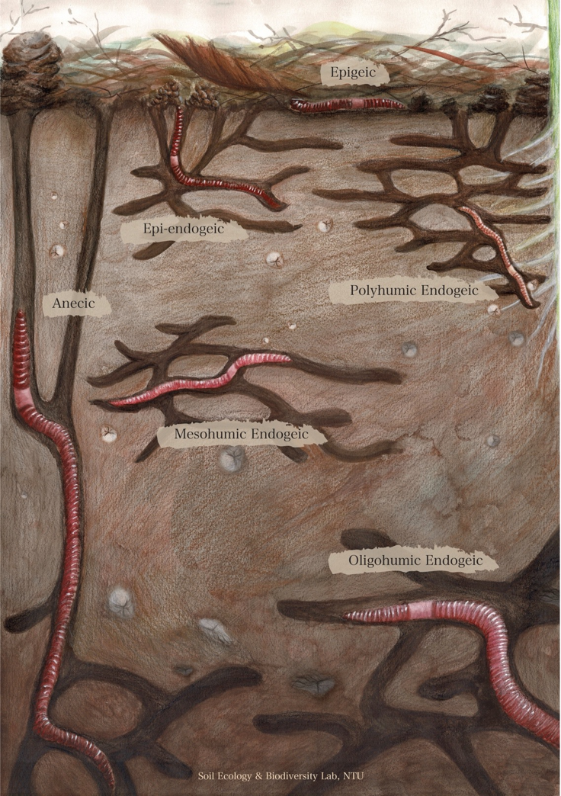

**Fig. 1.** Ecological groups of earthworms proposed by Perel (1975) and Lavelle (1981). In this system, earthworms are categorized into six groups that differ in body size, feeding and burrowing behaviors, and position (depth) in the soil, as illustrated in this diagram. Epigeic species are litter feeders living in the leaf litter. Epi-endogeic species are primarily litter feeders living in the litter-soil interface. They are found not only in the litter but also in surface soil. Anecic species are large-bodied litter feeders living in permanent vertical burrows deep in the soil. Polyhumic endogeic species are primarily soil feeders living in surface soil and feeding on fresh soil organic matter, such as root-derived resources. Mesohumic endogeic species feed on processed soil organic matter, live deeper than polyhumic species in the soil, and are also larger in size. Oligohumic endogeic species feed on highly processed soil organic matter. They are large and live deep in the soil.

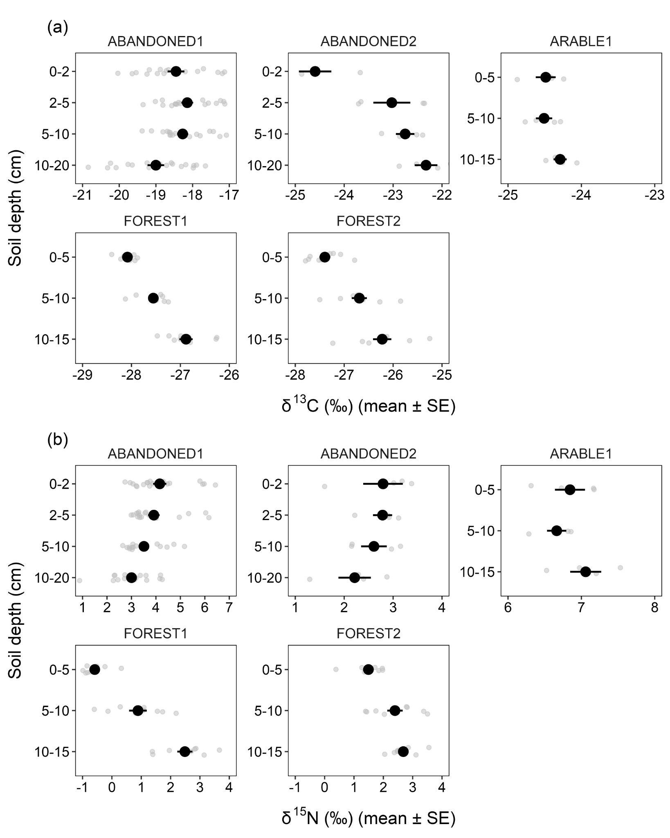

**Fig**. **2.** Stable isotope ratios (δ13C and δ15N) of soil samples at the five study sites. Black points and error bars represent the means and standard errors; original data points are shown in gray. Note the different ranges on the x axes. Y axes are not to scale.

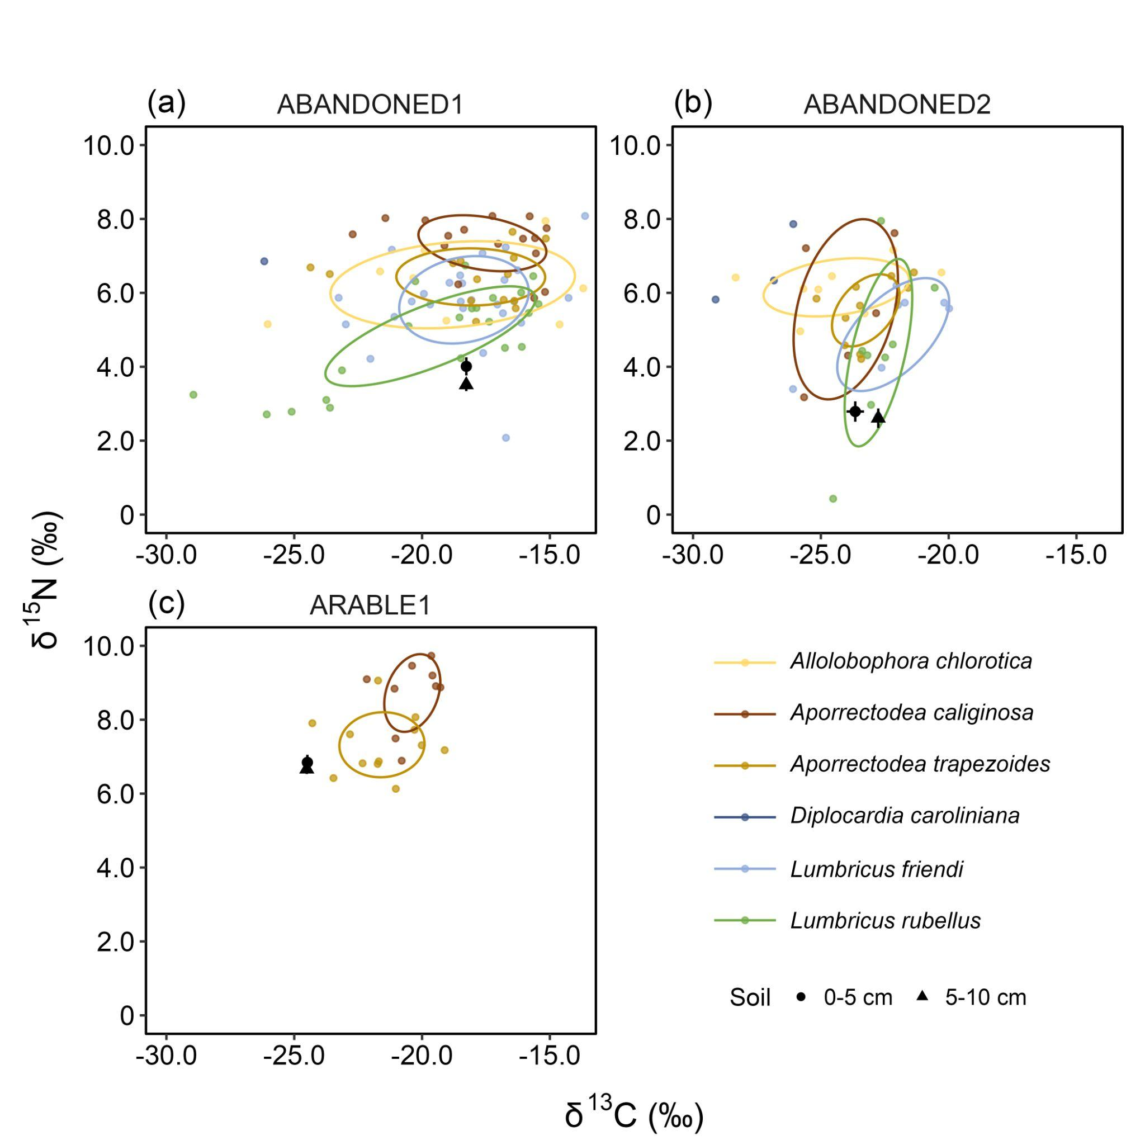

**Fig. 3.** Stable isotope ratios (δ13C and δ15N) of earthworm species at the study sites ABANDONED1, ABANDONED2, and ARABLE1. Ovals are Bayesian standard ellipse areas (SEAB) representing the core isotopic niches of each species. Black points and error bars represent the means and standard errors of the stable isotope ratios of soil samples at 0-5 and 5-10 cm depth. The isotope ratios of earthworm samples were standardized using background soil isotope signatures (see Materials and Methods for more details). Note that there is no oval for *Diplocardia caroliniana* because of insufficient sample size for computation of SEAB.

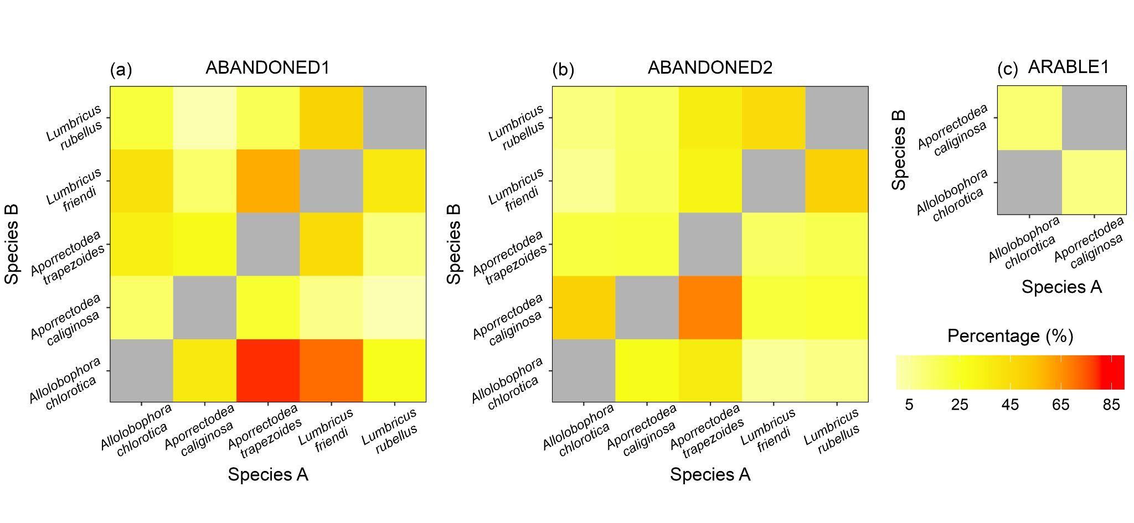

**Fig. 4.** The percentage of the SEAB of species A that overlaps with the SEAB of species B at the study sites ABANDONED1, ABANDONED2, and ARABLE1 (see also Appendix S1: Table S3 for the numerical results).

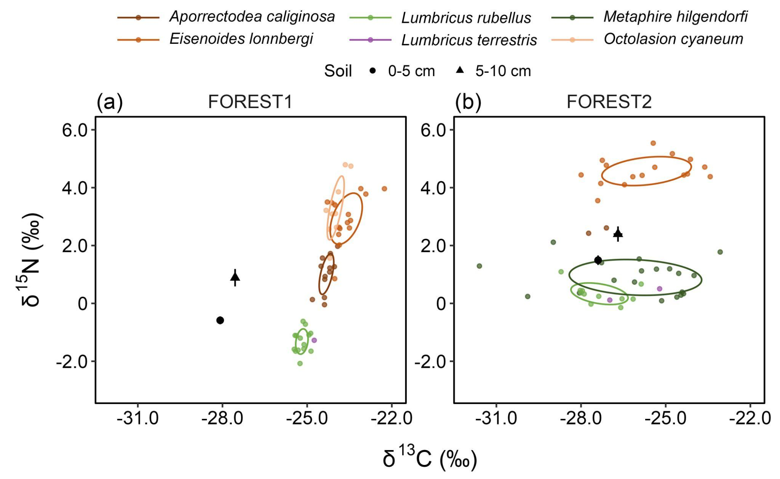

**Fig. 5.** Stable isotope ratios (δ13C and δ15N) of earthworm species at the study sites FOREST1 and FOREST2. Ovals are Bayesian standard ellipse areas (SEAB) representing the core isotopic niches of each species. Black points and error bars represent the means and standard errors of the stable isotope ratios of soil samples at 0-5 and 5-10 cm depth. The isotope ratios of earthworm samples were standardized using background soil isotope signatures (see Materials and Methods for more details). Note that there is no oval for *Lumbricus terrestris* because of insufficient sample sizes for computation of SEAB. Data from Chang et al. (2016). Replotted using soil for standardization.

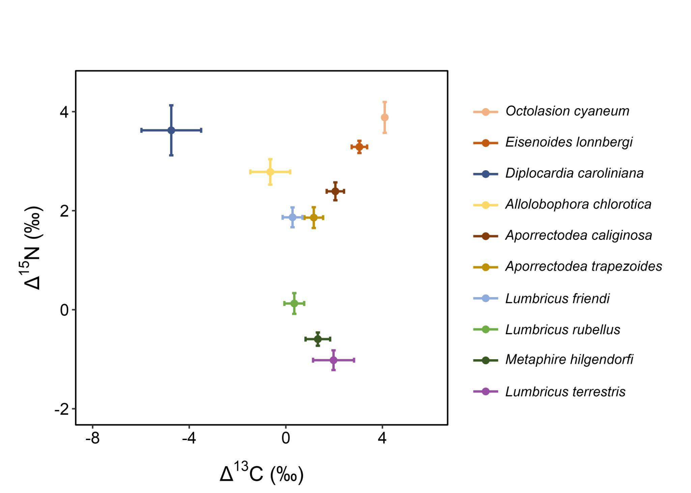

**Fig. 6.** The carbon and nitrogen isotope discrimination (Δ13C and Δ15N) between the soil and earthworm species across the five study sites. Points and error bars represent the means and standard errors of Δ13C and Δ15N. Total sample size *N* = 251.